Authority registration page and database creation
Run the DBconnection.py file. It shows output pointing to an object which means connection is successful.
Go to app.py file and run. Open the link in the browser.
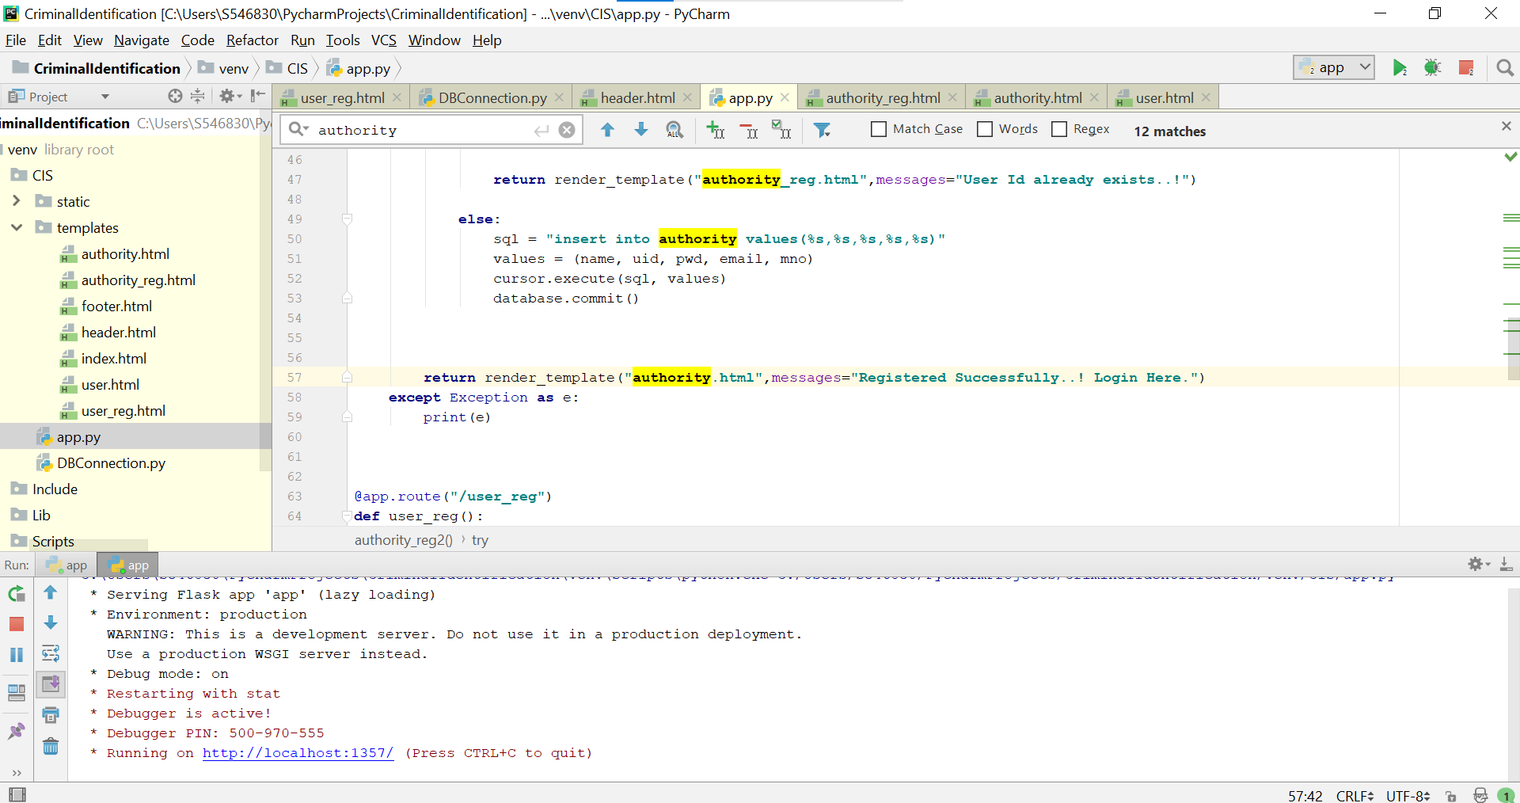

Click on Authority button to register as Authority.


In this first we will go to login page if already registered we can give login details if not registered we can click register fill the required details and click submit.
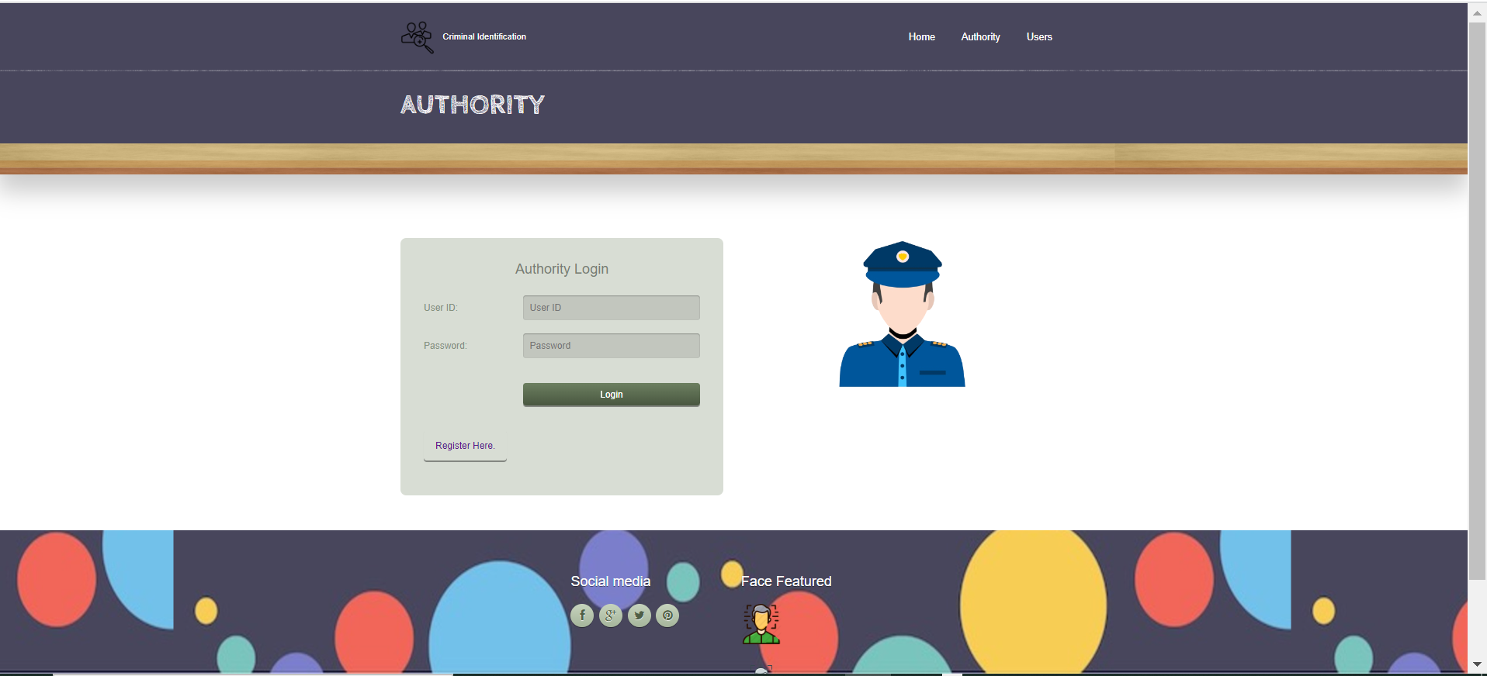

Code: to register – authority_reg.html
to login – authority.html
When registration is successful, check in authority table in database whether details are filled.
